Laycee Glass
OFM4 Task 2
Data Mining II
3/10/24
Western Governors University

OFM4 Performance Assessment, Task 2

Student Information
Student Name: Laycee Glass
ID Number: 001896026
Date: 3/10/24

Part I: Research Question

A1. Research Question
The research question asked for this task was the following: Can PCA uncover patterns in patient characteristics that are associated with hospital readmission?

A2. Goal of Analysis
The goal for this analysis was to use principal component analysis (PCA) to identify patient characteristics – such as age, hospitalization detail – that are most associated with readmission to the hospital. By uncovering these patterns, the hospital system can develop targeted strategies to reduce readmission and improve patient care and satisfaction.

Part II: Method Justification

B1. PCA Justification and Outcomes
Having too many features in a dataset can lead to several issues, namely overfitting and lower model accuracy. To address this, PCA is used to reduce dimensionality while preserving the most important patterns in the data. It transforms the original variables into a subset of “principal components,” which account for the most variance (Principal component analysis, 2025).
In our case, the dataset contains numerous patient characteristics, but not all of them are equally important to readmission. By applying PCA, we can reduce the number of variables while retaining the key information that differentiates readmitted versus non-readmitted patients. This allows for uncovering of the most influential characteristics associated with readmission to achieve our previously mentioned goals.
Outcomes expected from using PCA are a reduced set of principal components and identification of the most important features contributing to hospital readmission.

B2. Assumption
One key assumption of PCA is that the relationships between features are linear. It works by finding directions of maximum variance in the data, which assumes that meaningful patterns exist through linear combinations of variables. If there are non-linear relationships, PCA may not be the best approach unless transformations are made to make relationships linear.
Another important assumption is that features should be scaled. Since PCA is based on variance, features with larger numerical ranges can dominate the process, even if they are not the most important variables. To ensure all features contribute equally, standardization should be applied prior to performing PCA (A guide, n.d.).

Part III: Data Preparation

C1. Variables
The following variables were used for this task:
- Age
- Children
- Income
- VitD_levels
- Full_meals_eaten
- Doc_visits
- Initial_days
- TotalCharge
- Additional_charges

While Children, Full_meals_eaten, and Doc_visits are not continuous in nature, I have treated them as such due to the limited number of continuous variables in our dataset. These variables are discrete but have enough unique values to approximate continuous behavior. While not truly continuous, their inclusion helps preserve more information before dimensionality reduction. The inclusion may impact our analysis slightly, but standardization mitigates potential issues. In a real-world scenario, I would exclude these variables, but including them here provides a more robust set of initial variables (9 as opposed to 6), enhancing PCA’s ability to detect meaningful patterns.

C2. Copy of Cleaned, Standardized Variables
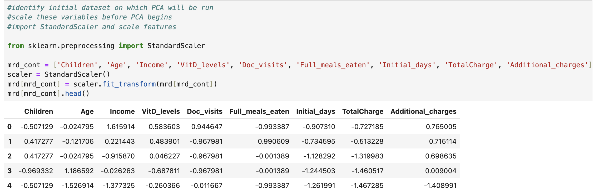
As stated, PCA relies on variance, so standardization was required prior to starting the PCA process. The exported, standardized dataset is attached for submission alongside this written report. The code for this standardization, and subsequent exportation, is shown below:
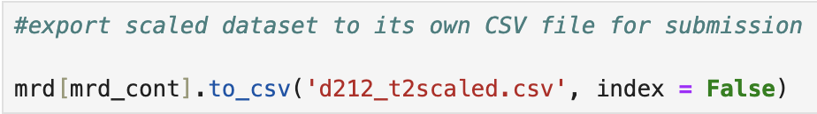

Part IV: Analysis

D1. Matrix of All Principal Components (PCs)
The matrix of all principal components, along with the code to generate it, is shown below. This matrix represents the transformed dataset that preserves variance while reducing redundancy and collinearity.

D2. Total Number of PCs
Initially, 9 principal components were identified. However, after applying PCA, we retained 7 components. Ideally, we would have reduced the dataset further, even to a single component, but PC1 alone accounted for only 22.1% of the variance. This was much too small to capture meaningful patterns. PC2 contributed 19% and PCs 3-7 each contributed between 10-11.5% of the variance (as shown below), making them significant enough to keep.
This decision was further supported by the scree plot, shown below, which illustrated an “elbow” at PC6 (corresponding to PC7 since the axis started at 0). The elbow indicated that PCs 8 and 9 contributed minimally to the variance and were not significant enough to keep. PC7 was retained because it still contributed significantly to the explained variance, while PC8 and PC9 showed a sharp decline in contribution, as seen in the scree plot and variance distribution
While PCA is designed to reduce dimensionality, our dataset did not allow for significant reduction, as only two features were effectively dropped.
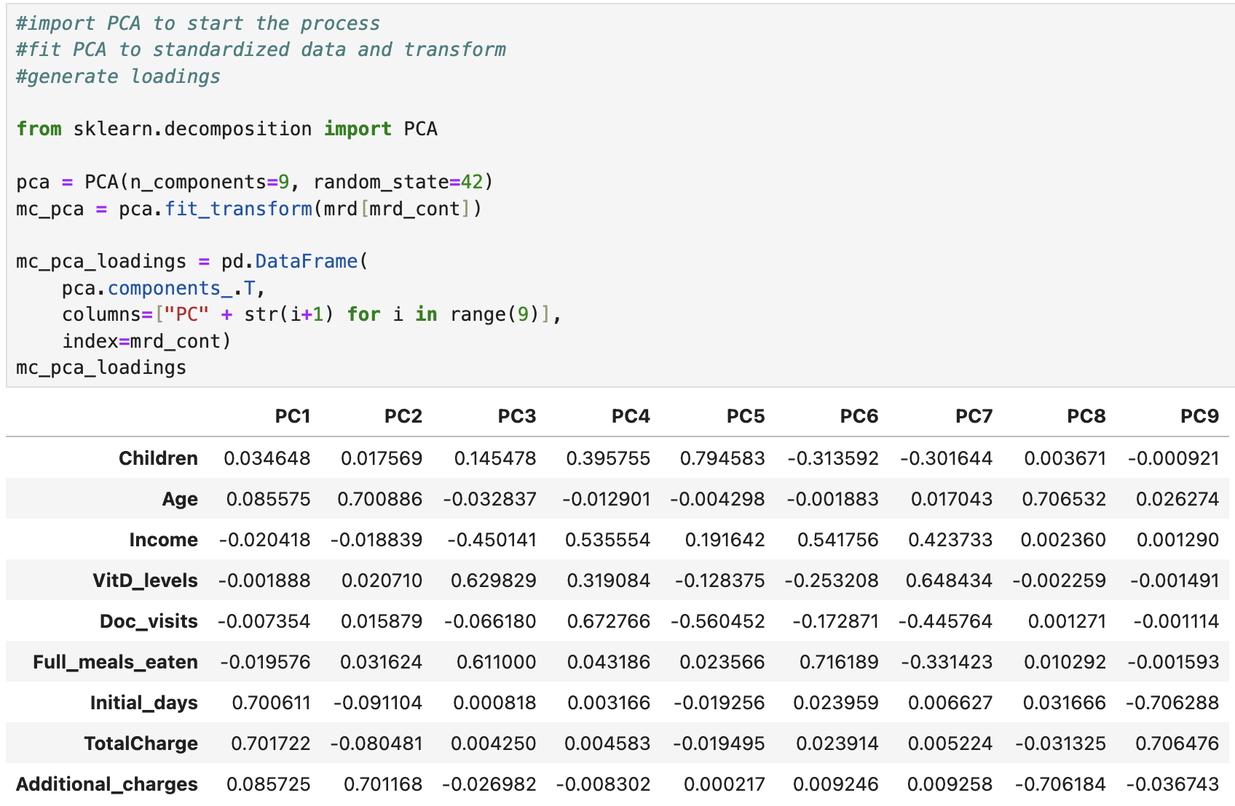

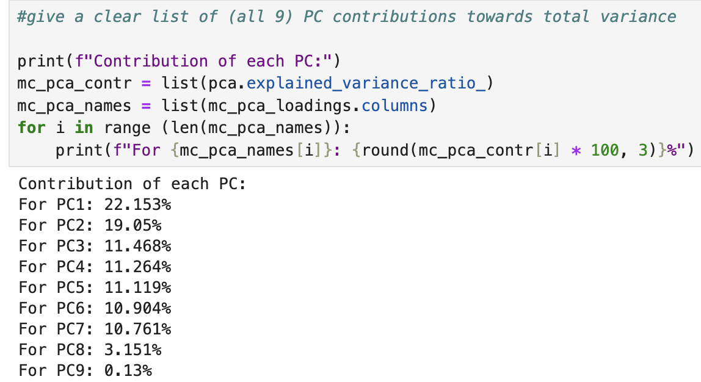

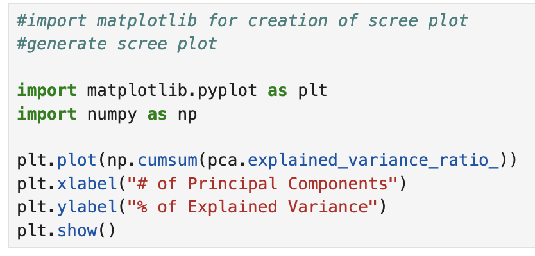
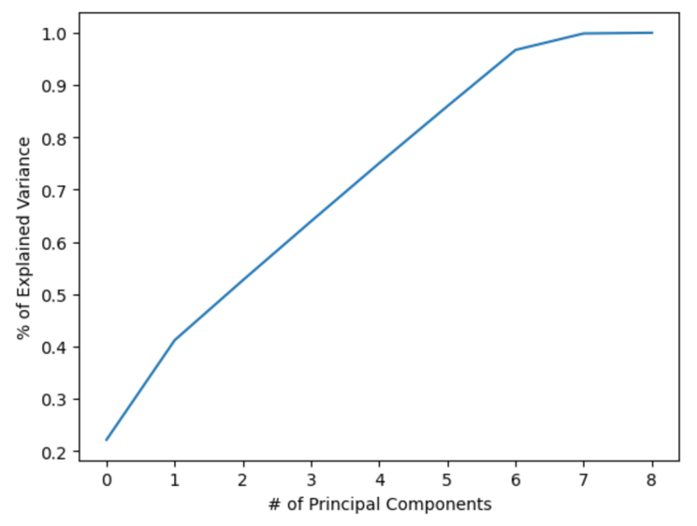

D3. Variance of Each PC
After determining that 7 principal components were significant to retain, PCA was then rerun with this parameter. The results from this final PCA, including its loadings, are shown below:

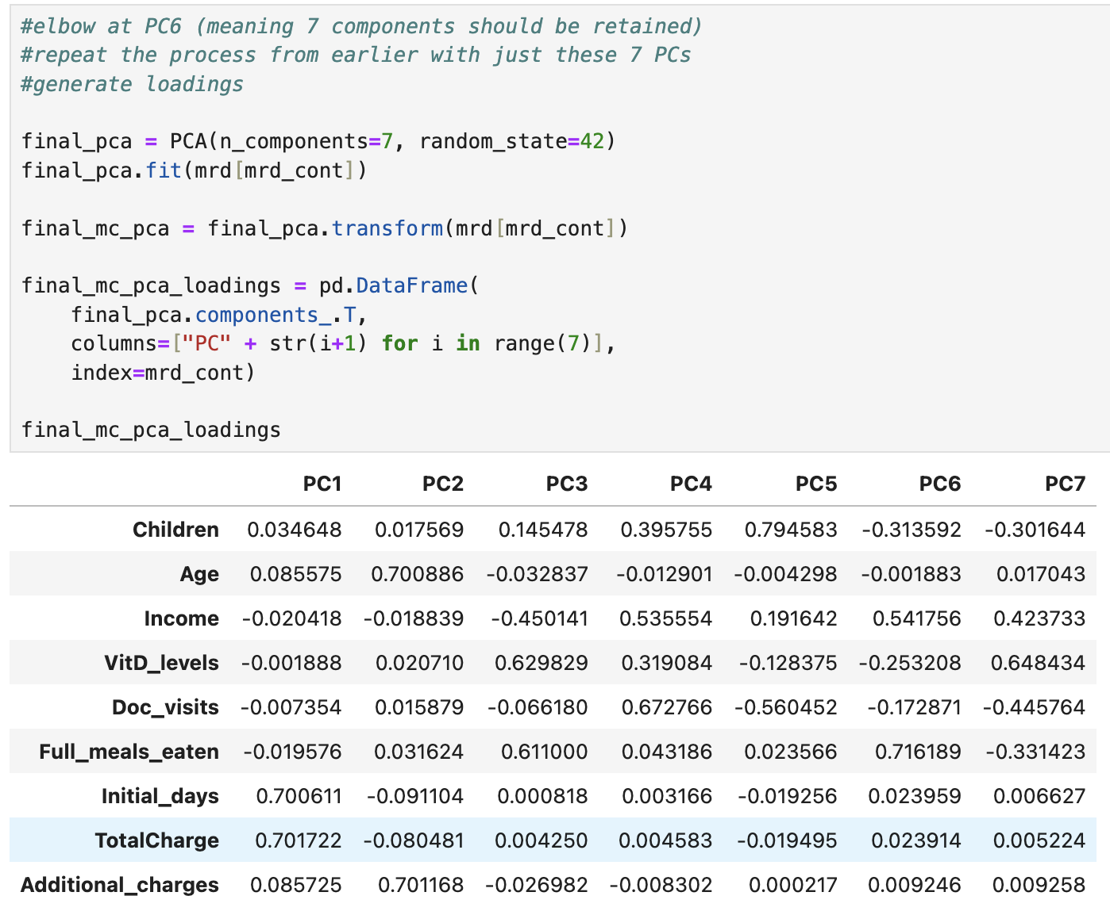
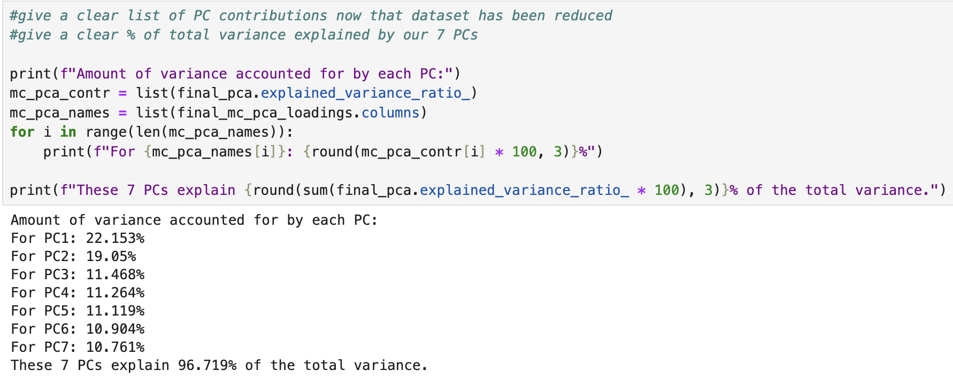
The contributions of each PC to the total variance remained unchanged (shown below), with PC1 accounting for 22.1%, PC2 accounting for 19%, and PCs 3-7 contributing between 10-11.5% each. Together these 7 components explain 96.7% of the total variance, making them sufficient for analysis.

D4. Total Variance of PCs
As stated in the last section (D3), PCs 1-7 accounted for 96.7% of the total variance in the dataset. This is shown in the above screenshot.

D5. Summary of Results
My research question and goal for this analysis was to identify associations with readmission of patients. PCA was applied to reduce dimensionality while preserving the most important patterns in the dataset. A total of 9 principal components were initially identified, but after evaluating the explained variance and scree plot, 7 PCs were retained. These 7 accounted for 96.7% of the total variance.
The model operated on 9 variables: age of patient, number of children, income of patient, the vitamin D level of patient during admission, the number of times the physician visited the patient, the number of full meals eaten during admission, number of initial days hospitalized, total charges accrued during admission, and additional charges accrued during admission.
- PC1 (22.1% of total variance) was primarily influenced by initial days and total charge. This could suggest that resource allocation is a key factor.
- PC2 (19% of total variance) was influenced by age and additional charges. This indicates there may be a strong relationship between age and cost of hospitalization.
- PCs 3-7 (each ~11% of total variance) were influenced by vitamin D levels, full meals eaten, doctor visits, income, and number of children. These reflect different aspects of patient health and socioeconomic factors.

Interestingly, initial days and both cost variables influenced only 1 PC heavily but had little effect on the others, whereas the others contributed to multiple PCs. This suggest that hospital resource use is a distinct dimension in readmission patterns, separate from demographic information and behavioral factors.
I initially expected the categorical variables, such as diagnoses (high blood pressure, diabetes, stroke, etc), complication risk, and type of admission, to be critical in predicting readmission. However, despite their exclusion, the model still performed exceptionally well, achieving a 96.2% accuracy score (as seen below). This suggests that patient readmission is highly associated with hospital stay characteristics and health behaviors rather than diagnoses alone.
While the accuracy was impressive, there is still room for improvement, especially in a healthcare setting where false positives and false negatives can have significant consequences. Future work could explore integrating categorical variables, additional clinical variables, and more reduction techniques to further refine predictions and enhance patient care insights.

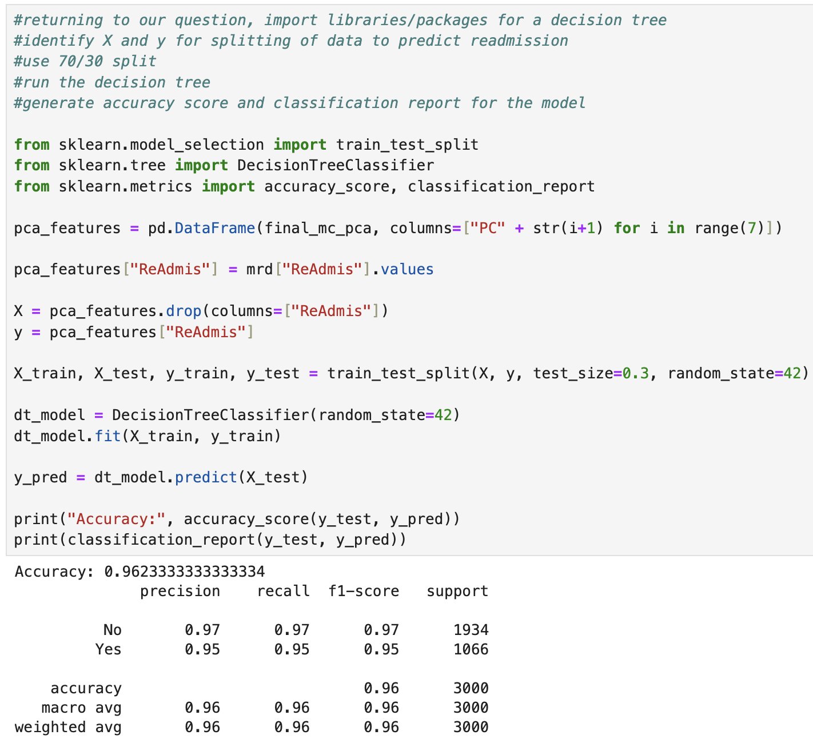

Part V: Attachments

E. Code Sources
D212 DataCamp courses
D212 Webinars

F. Text Sources
A guide to principal component analysis (PCA) for Machine Learning. Keboola. (n.d.). https://www.keboola.com/blog/pca-machine-learning#:~:text=PCA%20assumes%20a%20linear%20relationship%20between%20features.&text=That’s%20why%20it’s%20advised%20to,methods%20such%20as%20log%20transforms.
Principal component analysis(pca). GeeksforGeeks. (2025, February 3). https://www.geeksforgeeks.org/principal-component-analysis-pca/

